
Destination- Malaysia (Kuala Lumpur) + Singapore

No. Of Person: 2 adults

No. of nights – 6N 7Days

Hotel:3*

Package cost Per Person INR 53,000-/ Including Service Tax.

Complimentary & Insurance

Inclusions Malaysia (Kuala Lumpur)

- Daily Buffet breakfast at hotel

- 2Night stay at above mentioned hotel

- Kuala Lumpur to Singapore by Luxury Bus

- Half Day City Tour with KL Tower (Observation Deck Without guide) (4 Hours)

- Full Day Genting Highlands Tour with Photo Stop at Batu Caves with Cable Car Tickets

- All Sightseeing on Private basis

- Airport pick-up and drop Private basis

Singapore Inclusions:

- 3Night stay at above mentioned hotel

- Daily Buffet breakfast at hotel

- Half day Singapore city tour with guide (3hrs)

- Sentosa Magic (1 way Cable Car with Sentosa Cable Line, Madame Tussauds 5-in-1, and Wings of Time 7:30 PM)

- Universal studio (Adventure theme park)

- Airport pick-up & drop Private basis

- All sightseeing on Private/Shared basis

Exclusion:

- Any compulsory room supplement during the tour

- Video and Camera permits at sights

- Meals outside of the stated meal plan

- Use of vehicle other than the specified itinerary

- Expenses of personal nature

- Any other services not specified above

- Late check-out and Early check-in

Suggested day wise Itinerary
Day01: Arrive at the airport meet our representative & proceed to the Kuala Lumpur hotel check-in to the hotel day time is free for leisure & in the evening ready for the City Tour with KL Tower Tour (Without guide) | PRIVATE
Embark on an exciting Evening City Tour in Kuala Lumpur, featuring the iconic KL Tower, one of the tallest towers in the world. views of the city skyline from the Observation Decks (TH01 & TH04), offering unique perspectives of Kuala Lumpur’s landmarks.
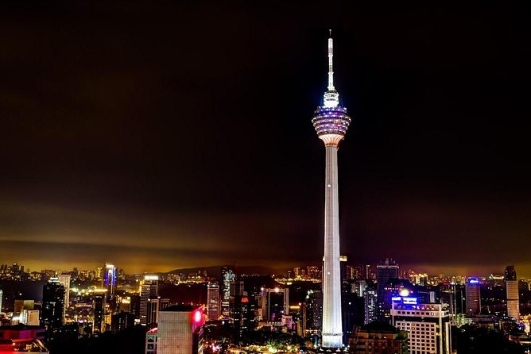

Day 02: Have breakfast at the hotel Full Day Genting Highlands Tour with Photo Stop at Batu Caves with Cable Car Tickets | PRIVATE
Embark on a high-altitude adventure to Malaysia’s sole casino resort, nestled 6,000 feet above sea level. Start with a scenic 20-minute stop at Batu Caves before venturing to Genting. Glide on the longest and fastest cable car in Southeast Asia to reach the hilltop, where the Chin Swee Caves Temple awaits amidst stunning surroundings.

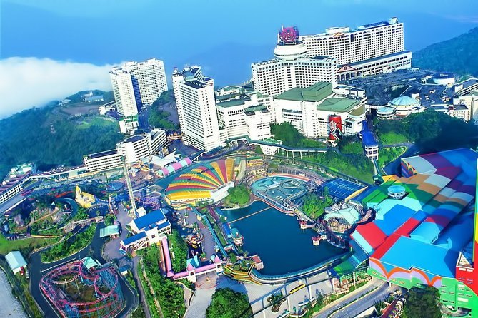

Day03: Have breakfast at the hotel then ready to take transfer for Kuala lumpur bus stand take bus for Singapore by bus it will take around 4-5hrs reach Singapore meet our representative & proceed to the hotel check-in to the hotel & overnight at the hotel.

Day 04: Have breakfast and get ready to embark on a full-day Universal Studios with sharing basis
Universal Studios Singapore offers an exhilarating adventure for all ages featuring blockbuster movie-themed attractions thrilling rides live entertainment and immersive experiences Explore seven themed zones from Hollywood to Madagascar and enjoy a day filled with excitement laughter and unforgettable memories.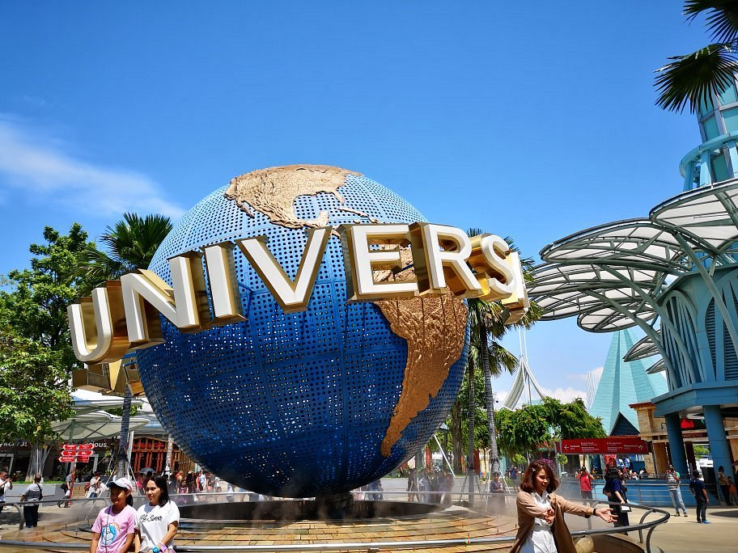

Day05: Have breakfast at the hotel then proceed to the Singapore Half Day City Tour with Guide (3 Hours) with sic basis
Embark on an exclusive exploration of Singapore with our private 3-hour city tour, accompanied by a knowledgeable guide. Drive through Singapore’s Financial District & business district followed by Drive through Suntec City. We will also cover a visit to the icon of Singapore, the Merlion at Merlion Park. Discover cultural landmarks and iconic attractions at your own pace, It’s the perfect way to immerse yourself in Singapore’s diverse culture and vibrant atmosphere.
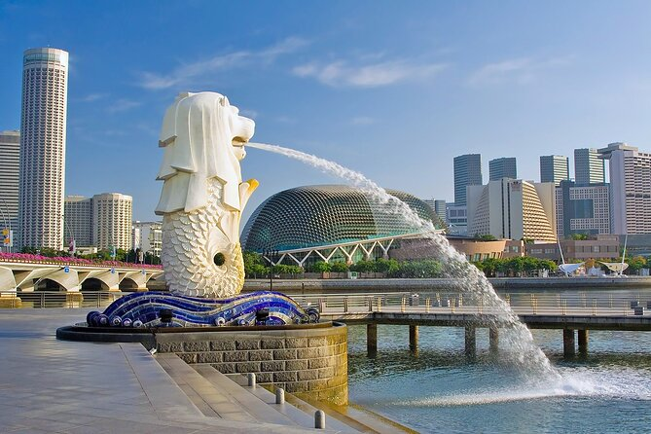

Same day in the afternoon Sentosa Magic (1 way Cable Car with Sentosa Cable Line, Madame Tussauds 4-in-1, and Wings of Time 7:30 PM) with sic basis

Conclude your day with the mesmerizing Wings of Time show at 730 PM In case of return pickup it will be done from Sentosa Coach Park To make your way their head towards Monorail Beach Station First Then follow the signboards guiding you toward Sentosa Coach Park from underneath the bridge Use the escalators to ascend and reach Sentosa Coach Park where your pickup will be arranged.
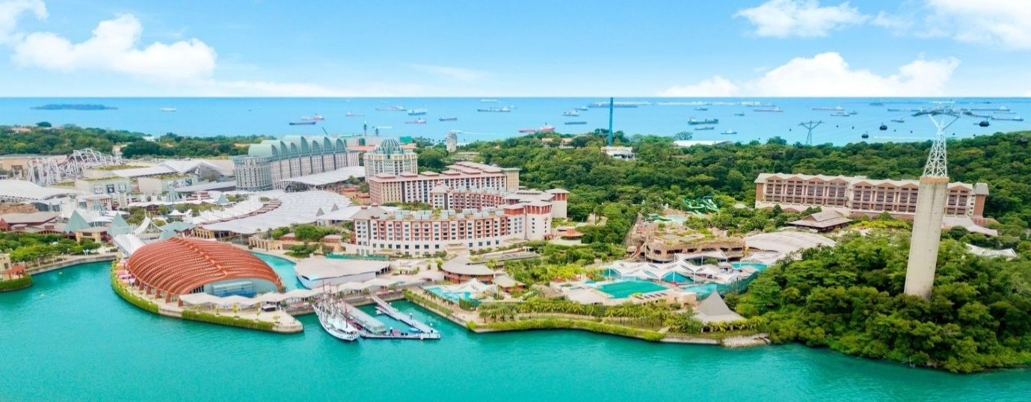
Day 06: breakfast at the hotel then transfer to the airport according to your flight timing.

